|  |  |
| --- | --- |
| **I want to learn new words.** |  |
| **I want to learn to read short texts.** | |
| **I want to improve my spelling.** |  |

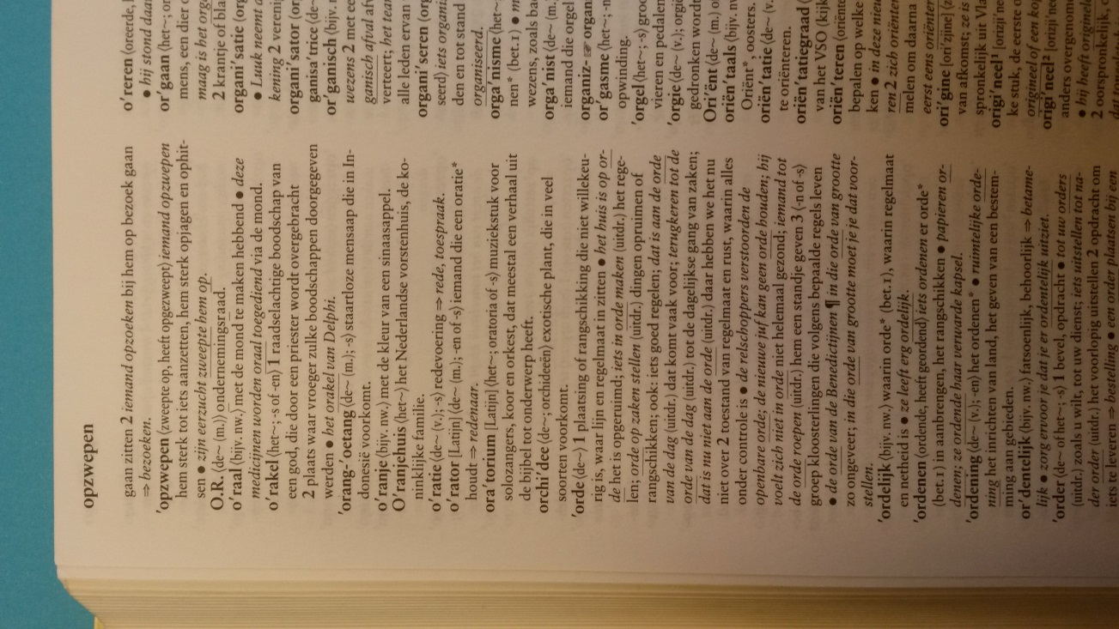*Goals setting Cards*

|  |  |
| --- | --- |
| **This week I have a writing tasks.**  **I want to learn to perform this on my own** |  |

|  |  |
| --- | --- |
| **I want to learn to read faster.** |  |

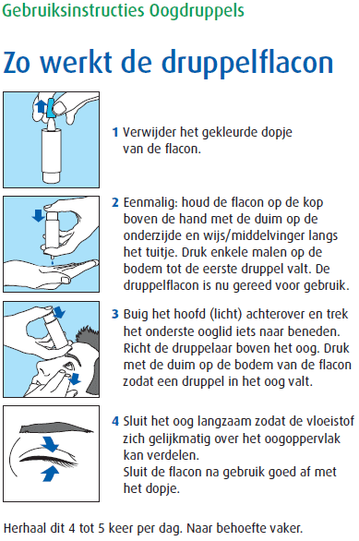

|  |  |
| --- | --- |
| **I want to learn to understand the instructions for my medication.** |  |

|  |  |
| --- | --- |
| **Monday** | **Friday** |
| **Tuesday** | **Saturday** |

*Planning Cards*

|  |  |
| --- | --- |
| **Wednesday** | **Sunday** |
| **Thursday** | **I’m going to find time to learn.**  For instance: When the children are at school, I will go to the library. There it is quiet enough to concentrate. |

|  |  |
| --- | --- |
| **I’m going to ask for help.**  For instance: family, friends, colleagues, class mates. | |
| **I am going to look for material that helps me with learning.**   * I am going to look for material in the library * I will ask the teacher of my school * I am going to look on internet. | |
| **I an going to use WhatsApp.** |  |

*Strategy cards*

|  |
| --- |
| **I’m going write in a diary what I learn.** |

|  |  |
| --- | --- |
| **I am going to read short articles in the newpaper.** |  |
| **I am going to look for the important words in a text and underline them.** |  |

|  |  |
| --- | --- |
| **When I read or hear a new word, I will look for it in the dictionary.** |  |
| **I will ask my conversation parter to speak slowly.**  **I will write down new words I hear.** | |
| **I will write down new words in a word list.**  **I will use what I have written to learn the new words.** |  |
| **I am going to use word cards I make myself.** |  |

**Blanco cards**

|  |
| --- |
|  |
|  |
|  |